A message from Doc Searls for March 31st People Centered Internet Meeting
The key issue is personal autonomy. Not just strength in numbers, but strength in independence, leveraging the end-to-end nature of the Net and its founding protocols.

Observation: while the Net’s design is peer-to-peer and end-to-end, the Web’s is client-server, which is basically slave-master, or what some of us call calf-cow:

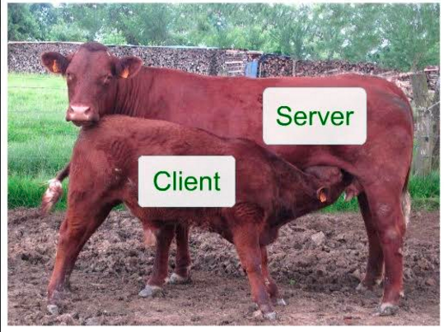

We, the client calves, go to the server cows for the milk of “content” — and cookies.

These days we also get tracked like animals (via cookies and other beacons) by parties unknown, which is as rude as it is normative. There are good actors among those parties (such as Google, which is not among the unknown), but there are also bad ones aplenty, which is why privacy is such a huge issue.

To empower individuals, we need to make them fully human again, and not just what marketers seek to “acquire,” “control,” “manage” and “lock in” as if they were cattle or slaves.

One way is with terms of their own, which Customer Commons is working on: http://j.mp/mitermz.

There should be others as well, and I hope those are subjects of discussion.

Meanwhile, another link: http://j.mp/g1antzero.

Doc and Joyce Searls

March 30 2016

