Contribution of the People Centered Internet Forum
October 24-25 at Stanford University
The Internet can be a powerful means to continuously improve people’s lives. It deepens the layers of connections between countries, communities, businesses, social benefit enterprises and international agencies. We recognize that the greatest barriers to digital opportunity are both social and economic, and that the heights of these barriers require us to “think anew and to act anew.”
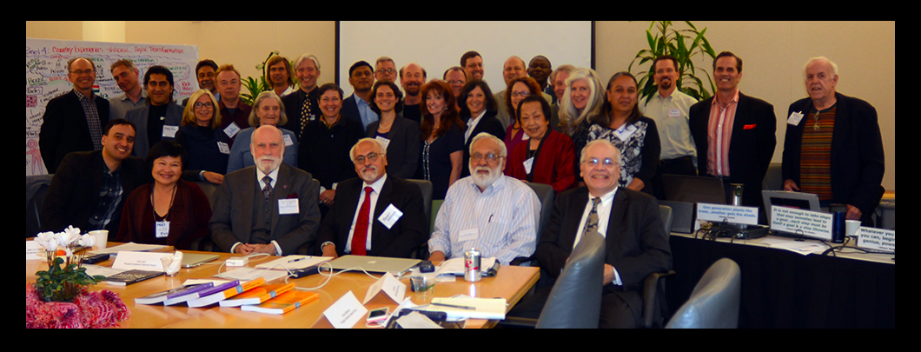
Seated: Secretariat of the People Centered Internet - Manu Bhardwaj (US State Dept.) Mei Lin Fung (Organizer, US & Singapore), Vint Cerf (Chair, US), Nagy Hanna (Advisor to the World Bank, US), Anil Srivastava (Open Health Systems Laboratory, US), Ahmed Calvo (Stanford Haas Center for Public Service, US & Costa Rica)
Standing: (L-R) John Mitchell (Vice Provost Teaching & Learning Stanford, US), David Nordfors (I4J, US & Sweden), Vince Kohli (Future of Empathy, US & India), Eileen Clegg (Visual Insight, US), Virgilio Almeida (Brazil), John Ryan (Wire the World, US & UK), Lynn Gallagher (ex-USAID, US), Madis Tiik (Tallinn University, Estonia), Mark Finnern (Thrivable Future Salon, US & Germany), Monique Morrow (Cisco, US), Deepak Mishra (World Bank, US & India), Ray Jeter (Air Force, US), Anna Waldman-Brown (Maker & Hacker spaces, US), John Matttison (Kaiser Permanente, US), Kimberly King (One Island Institute, US), Bruce Green (US), Peter Forsyth (Wikipedia community, US), JacQualine (Intuition Power, US), Steve Huter (Network Startup Resource Center, US), Valerie Landau (Samuel Merritt University, US), Ndemo Bitange (University of Nairobi, Kenya), Effie Chow (East West Academy of Healing Arts, US), Stefan Nachuk (UCSF, US), Shannon McElyea (Friend-Raiser, US), Lucienne Abrahams (LINK Center, University of the Witswatersrand, South Africa), Jeff Richardson (South Bay Organization Development, US), Chris Bui (The American Focus, US), Bill Daul (NextNow, US)
Not in photo: Rene Summer (Ericsson, US), Paul Greenberg (The 56 Group, US), Vincent Everts (Video blogger, Netherlands), Dan Desmond (The Simi group, US), Dan Esbensen (Touch Technologies Inc., US), Mindy Hill (San Carlos School District, US), Bill Fenwick (Fenwick & West, US), Kennan Salinero (Re-Imagine Science, US), Wayne Jonas (Samueli Institute, US), Linda Neuhauser (UC Berkeley, US), Jack Park (Topic Quests. US), David Price (Debategraph, UK), Mark Cullen (Stanford Center for Population Health Science, in the School of Medicine, US), Lorene Nelson (Stanford Center for Population Health Science, in the School of Medicine, US)

The Internet is a powerful instrument for two essential complementary movements: Empower People - augment their human capital (health and education), raise their collective voice and improve the business and natural environment. Transform Institutions and Organizations (public agencies, businesses, civil society organizations) – engage the power of Internet and digital technologies with social intermediaries, innovators and connectors. Community leadership and civil society organizations are crucial in augmenting the voice of the global poor and all others left out, with the social connections and digital literacy to benefit from universal, affordable, open and safe access.

Uptake of the Internet is deeply dependent on what it enables, socially, educationally and financially, for the people of the world. We must pay attention to how to provide dignified and respectful Internet access for the disabled, elderly, homeless, migrants, poor and non-English speakers. Investments in physical infrastructure and development of business models must be adapted to achieve inclusiveness and the development of applications serving the needs of a diverse population of users. The Internet we need has a set of properties we set out below:
1. Complete universal Internet coverage that enables functionality that is otherwise unreachable or ineffective
2. The Internet is affordable, open, available and accessible to all
3. Fosters digital literacy, local content in local language to achieve widespread usage and increased value to people, families, communities and countries
4. The system achieves a level of trust that meets the users’ expectations of affordability, privacy, safety and security
5. The quantity and quality of educational and information services is increasingly available to families and communities
6. Anyone can contribute to improvement of the utility of the global Internet.
7. Personal information in the digital environment is protected by law and controlled by the individual owner.
In a one and a half day meeting, an initial complement of interested parties developed a list of elements that could drive the agenda for a People-Centered Internet program, as set forth below:
a. Align PCI program goals to support the 2030 UN Sustainable Development Goals in education, health and other development objectives.
b. Build trust and inclusion to bridge generations, nations and cultures
c. Empower women and youth with relevant Internet content to better equip future generations
d. Support locally-led initiatives and grassroots innovations as well as top-down policies and reforms to support scaling up of promising innovations to improve human lives in diverse contexts.
e. Develop narratives to influence decision makers to leverage ICT to transform their economies, institutions, and societies.
f. Promote research, innovation, and knowledge sharing in best practices in national policies and strategies to advance digital transformation in government, economy, and society and maximize the digital dividends of the Internet.

If interested in further engagement, please send email to PeopleCenteredNet@gmail.com

A. Lincoln 1862
UN Sustainable Development Goals for 2015-2030 were approved on the 70th anniversary of the United Nations https://sustainabledevelopment.un.org/topics Transforming our world: the 2030 Agenda for Sustainable Development

