PALISADES ACADEMY ON THE HUDSON
NEW YORK REGION
(Site is behind photo ¼ mile)

Palisades Academy occupies a breathtakingly beautiful site near the Hudson River. Just north of the George Washington Bridge passageway into New York City, the natural beauty of the Palisades offers a serene environment for reflection and learning to learn. The Academy’s multinational faculty prepare youth for international leadership roles in a changing world. Its innovative pedagogy integrates the best practices from many world renowned institutions in preparing students for continuous learning and access to the world’s most prestigious organizations and institutions.

The Academy is one of the first preparatory high schools in the US with a focus on preparing youth to become international citizens via preparation in varying languages and world cultures, to master ideas in mathematics and sciences within a systems sciences framework. To achieve this it draws from the heritage of the decades old IBM Center for Advanced Executive Education.

IBM PALISADES EXECUTIVE EDUCATION CENTER
LOCATION/PALISADES

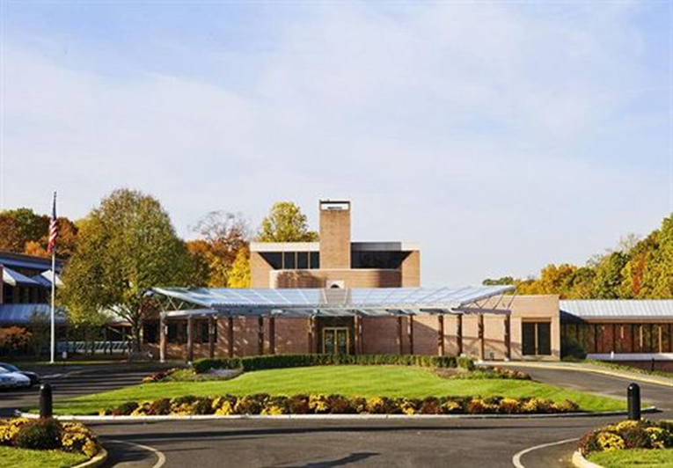
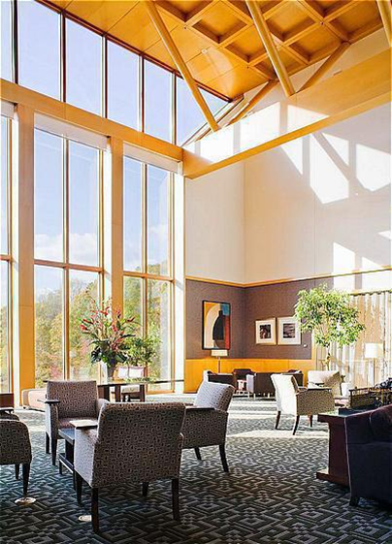

The entry to the Center welcomes participants and visitors to graciously appointed spaces flooded with natural light and views onto the natural settings surrounding the buildings.
Graduates leaving the Center are prepared for advanced education, noteworthy employment experiences and other exciting opportunities.
Arriving from all parts of the world Academy graduates will leave as confident international citizens, prepared to make a difference in the world they have come to appreciate. They will carry their family’s cultural base, knowledge and honor with them in the respect of other cultures, and mental models of the human project. They will leave well prepared to fit new information into the world map they acquire.
Those wishing to become part of leading programs in leading universities of the world will find the Academy prepares them to realize their dreams. Consistent with leading high schools, graduates will have the option of working in public service in leading world organizations prior to or after advanced education.
Instruction in the fundamentals of the humanities, math and science provide a platform for successful life-long learning. Staff will encourage personalized understanding of the world by making use of the fundamentals. Students will then be encouraged to go beyond the fundamentals to identify questions that motivate their lives. The learning theme is with how improved questions, not answers, have long been the basis of significant scientific and societal progress. Questions are at the center of higher understanding in all disciplines and endeavors. Aspects of cross-cultural humanities, concern for others in individual acts, and responding to change via Silicon Valley style innovation will be combined with East Coast traditions in learning and will instill confidence in graduates.
Individual and group learning processes at the Academy are used to initiate further development of student aspirations. Academy faculty seeks to transmit, in the words of the eminent anthropologist Gregory Bateson, the differences that make a difference. This includes the discourse on the often ignored concern with ethical differences between what is and what ought to be in science and society.
The Academy sits on a pristine site in lower New York State nearby the world acclaimed cultural and commercial resources of New York City. The facility thus provides an ideal setting for learning to meet the future from the vast experiences of others. The prior occupant, IBM Palisades, was for decades a stage set for leaders of Fortune 500 companies that resided at the facility and participated in IBM Executive Leadership Seminars. The best and brightest researchers in many subject areas lectured at the facility. This tradition will be continued in the Center. Some of the same leaders will be invited back to motivate high school audiences. Palisades was long been known in the region as a beautiful learning environment that IBM’s founder, Thomas J. Watson, initiated as an education site. The architecture of inspiration is carefully situated in a very beautiful natural setting. Palisades truly stimulates the human psyche while nurturing optimism about the potentials in a human future that can complement living systems.
THE FACILITY AND ITS MANAGEMENT:
The facility is carefully managed by a staff concerned with the safety and wellbeing of the students.

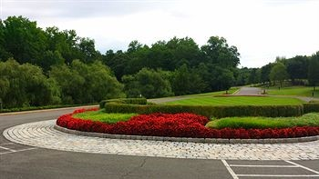

The facilities and site are conducive to various sized group meetings. A variety of inside/outside spaces are easily available, all designed to enhance intensive social interactions and/or invite private reflections. Beautifully landscape gardens surround the gracious architecture. Nature is an integral aspect of learning at the Academy. Leading edge technology has always been key to the management and continual improvements to the facility. Super High Speed internet fully linked into cloud computing allows high quality communication with parents and others relative to course work. Streaming video offers additional opportunities for inbound and outbound cloud based education. The changing world thus becomes more accessible as well as supportive of learning.
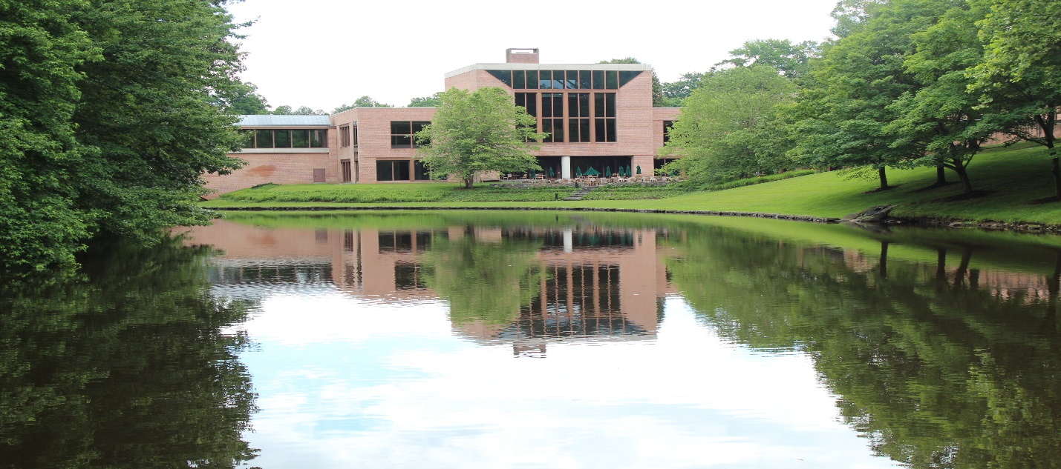
Students living on campus will be housed in beautiful rooms. The structure for the initial dorm is in the following picture. Additional dorm rooms will be built in the near future.
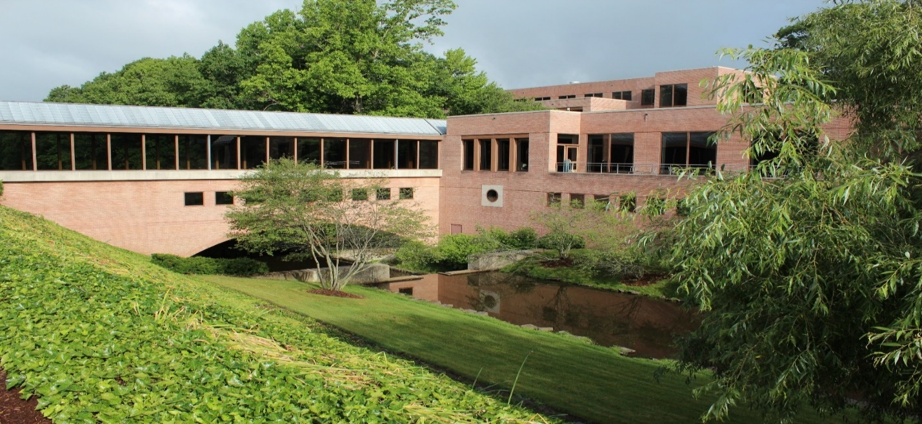

Breakout, refreshment, seminar spaces are plentiful and inviting at Palisades. The image below captures the essence of the indoor/outdoor space qualities of the School.

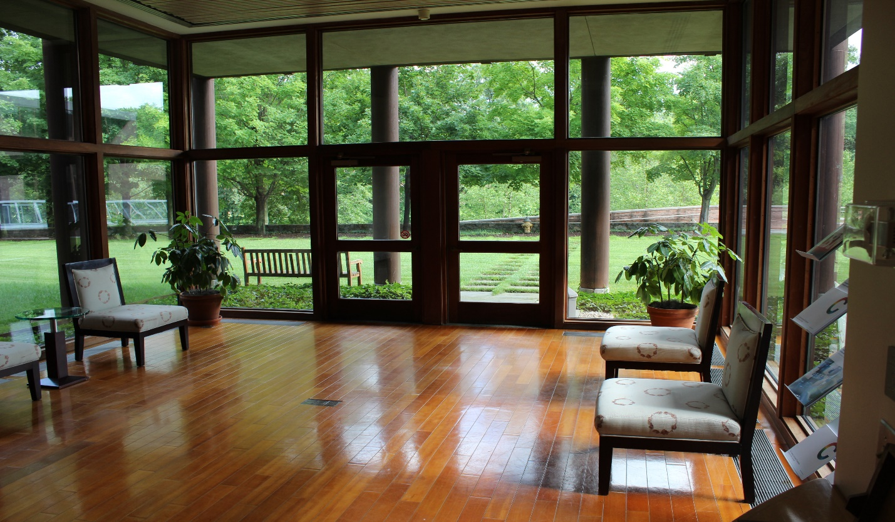

ACADEMY PRICE: $60,000
Tuition is $40,000/year. The fee covers instructional facilities, instruction, books, materials, field trips, and information technology. An additional $18,000 covers costs of housing, food and entertainment. $2,000 in fees covers extra-technological and extra-curricular costs.
ADADEMY MISSION: IMAGINATION, INTEGRATION, INNOVATION
The Academy is unique in the educational community in that it emphasizes learning via three essential ingredients to dealing with a changing world, imagination about what could be, integration of parts into a picture of what could be, and an intrinsic spirit for innovation to attain the first two. In line with this we offer an educational context that supports imagination, systematic integration of separated subject matters, and encouragement of innovation via emphasis on learning as questioning the presumptions for the existing situation. Instead of the long standing norm of routinized education the teachers in Palisades emphasize ways for learning to learn.
This non-public educational platform is operated in the context of the larger US public education system. Public and non-public spheres of education, as seen in the most recent Department of Education documents, encourages ways to find and/or invent new pathways. Both aim to foster educational improvement for students for a changed and changing world, one where the parameters of success are continuously redefined. Certainly there are differences of opinion but most involved agree that the status quo is insufficient. We have selected the non-public approach for Palisades. We believe it offers the flexibility essential to the future of education. A variety of methods and modes of learning are used, where all have been successfully used in other various parts of the world. All draw from the belief that imagination is not only allowed in the classroom, but treated as a crucial attribute to the human condition.
For example, imaginative uses of representational and gaming technology, as related to innovation, have been shown to be successful in math instruction. This approach to understanding and appreciating math can then be used to greatly enhance imaginative re-representation of problems. The Academy makes use of some of the best thinking from the most imaginative international minds. Experimental ideas seen in the founder of “Angry Birds” illustrates the potential. He has written on ways of educational reform via innovation in Finland, where Finland is already seen as the second most successful nation in educational achievement. Other illustrations of the same approach can be seen in the creative minds of people like David Snow, former head of Medco, where technology would be applied to individualized health care via new forms of representational health testing and monitoring via clothing. Our list will also include highly motivated people such as Dr. Eric Hoffman, Director of the world’s foremost research lab on medical imagining technology. Such thinkers will be regular visitors to the Academy to inspire the students on the importance of learning instead of knowing.
Systemic Integration of Subjects Presented as Separate: Academy Students will access reservoirs of knowledge, formerly known as “subjects.” The four traditional subjects of traditional high school education will be common to all students, but only as a beginning. What is different in the Palisades is the emphasis on systems science approaches to value the integration of ever increasing segmented areas of knowledge. In addition to integrating what is known in the four subjects, students are encouraged to select additional subject areas and societal challenges with which to integrate the four fragments. Each student may arrive at a distinct and unique image of their future to carry with them. This model of learning is to inspires and motivate, and to generate the innovative responses needed today and tomorrow.
The Academy and its staff emphasize motivating young adults to understand social and technical leadership processes, how they are similar and different, and what leadership means in both areas. Our graduates will understand the role of vision in leadership, where vision moves the edges of knowledge forward. These once were seen as the role of advanced university training in such courses as Ontological Business. Some concepts from this course are now part of a well prepared application to leading university undergraduate programs.
Emphasis on Learning. Education at Palisades is seen as the process for the acquiring the operating assumptions needed to operate in society. These assumptions relate to how the world currently works as well as how it fails to work. Current emphasis on analytic approaches favors concentration on the former, how the world works. We move forward from this to synthesis where questions of improving how the world works arise. In so doing our students look for the differences that make a difference. This requires unique educators that often know several subjects, are aware of the limitations of each subject; i.e., the edges of knowledge in a subject, and then look to means to push the edges forward. Our faculty encourages and addresses questions as to why something should be assumed. This requires faculty well-schooled in the history of a subject, its accomplishments and its challenges, as well as few students per instructor. In this way the educational process shifts from education to learning.
LEARNING:
Learning is of a different logical type than education. At the Palisades it is the process for questioning presumptions about what works in order to improve the working. This is the implicit to endeavors to improve education, yet often seen as a barrier to efficient education. Where learning appears students are encouraged to conceptualize and raise the questions that lead to improved questions instead of answers. Long recognized as the driver of advances in an evolving technological society this requires a different approach to schooling. Our approach encourages questions in the classroom, not answers. The answers are usually pretty easy. It is noteworthy that the greatest advances in science have come from those who seem to have had the most difficulties with current assumptions about science and society. Einstein and his “limitations” have long been seen as an example of this. He, based on the intelligence he brought to class, had trouble accepting the role of Newtonian physics and Euclidean geometry. Leading scientists often remark that unless viable responses to a problem are contradictory the problem is not worth their time. More recent examples are seen in leaders of the most technologically advanced companies being drop outs from schools teaching the subjects they challenged. Palisades takes advantage of this traditional educational dilemma and not only retains such future leaders but strives to support their explorations into making the impossible possible.
It has also long been known and commented upon that the best way to learn is to teach. This has seldom been applied in an educational institution. It is being experimented with in some of the most advanced on-line learning. We will learn from this and build on it in classroom as well as online learning. Students will make presentations to other students, requiring they learn about a subject in order to be able to teach others about its ideas and evidence. This is to rise above the spreading approach of teaching students to prepare for the “exams” by developing their memorization and forgetting capabilities. It is interesting that schools that most avoid standardized testing prepare students the best to pass standard international tests. Our educational mission will continue to be informed by and learn from such accomplishments.
THE FACILITY AND ITS FACILITATORS:
Education at the Palisades takes place in beautiful, well equipped lecture rooms, such as those seen in the images that follow. In addition, a variety of outdoor laboratories will help students understand and carry out experiments into the presumptions of systemic relationships between technology, nature and humans. Examples of these outside labs are seen in the most successful private schools in the Western United States. They offer a variety of student designed green labs, symbiotic greenhouses, energy collection and distribution networks, and alternative food production. These are unusual in East Coast Private Schools with limited sites.

Education at the Palisades takes place in beautiful, well equipped lecture rooms, such as those seen in the images that follow. Learning is emphasized in the larger spaces via highly motivating speakers. In the smaller spaces learning emerges via interaction between fewer students in interactive discussions and presentations. This is similar to the salon approach. Additional Academy spaces conducive to learning are depicted in later images. Additional learning spaces are found in landscaped areas, science labs and experiment stations found around the grounds.

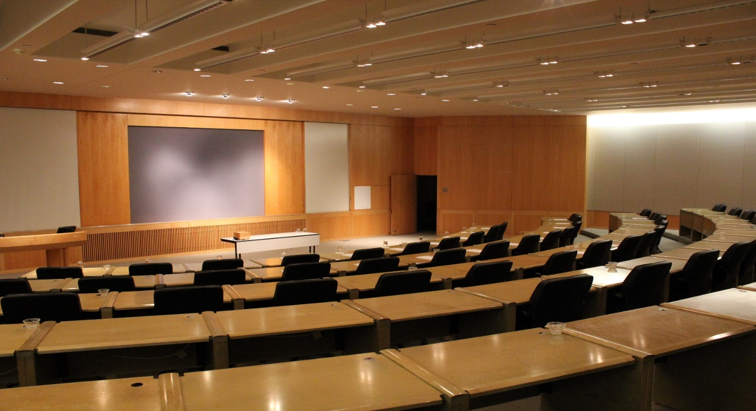
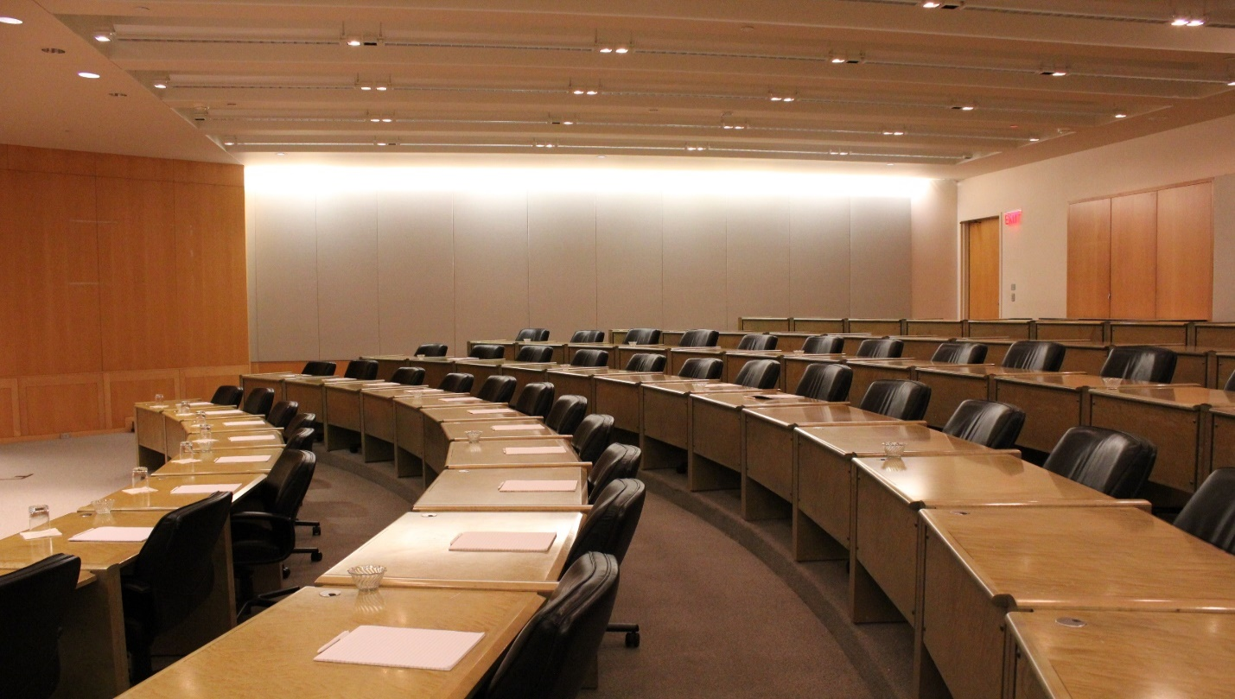
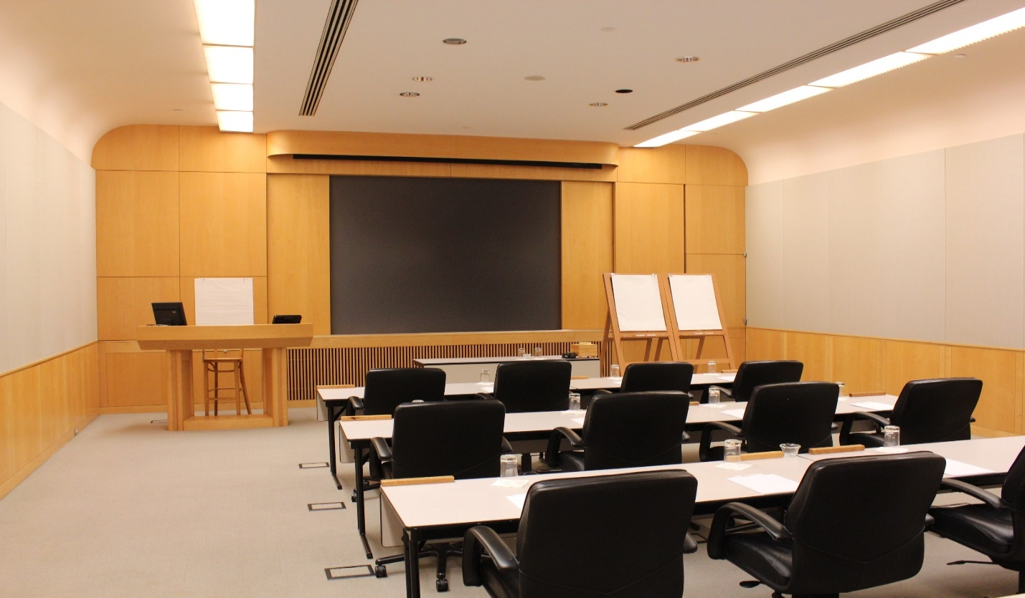
Our learning facility has been designed to actively facilitate teaching that goes beyond the avenues of traditional education. The facility and its teachers, its “instructional mangers,” will open up in-depth and systemic examination of the assumptions that define the usual. Palisades accepts the fundamental role of education in modern society but then builds on this to push those fundamentals closer to the edges of what is now known, and unknown. Our school is organized to encourage creative discovery of newer edges, of what lies beyond “what is,” to investigate the ethical/normative worlds of “what could/ought to be.”

The process of testing of assumptions seems necessarily less efficient then faithful memorization and recitation of long standing and often counterproductive rules, but due to the passion it encourages it can in fact be more efficient. The increased motivation of the participants more than compensates for time seeming to be lost in entertaining their questions. Questioning of accepted assumptions has long been the means of progress in science, society and human development. Questioning, via dialogue and experimentation, is fundamental to learning as well as learning to learn. In this way society meets future challenges. This has been the basis for societal evolution and progress including our current shift from industrial to the information paradigms.

The information paradigm involves a greater use of human creativity simply to visualize the worlds of what ought to be, as motivated by experiences in negotiating with the limits of what is. Learning to learn which has long been known to be the best means to prepare for the challenges of what is unknown about tomorrow’s world. Our mission is to help graduates to better participate in the long term process of being human. Our staff and instructors will be carefully selected and managed to support students standing at the edges of knowledge and seeing wonder in what could be. The advantages of transparency via an open systems approach can be seen in the in the faculty and facility. Dormitory spaces, seen below, will allow for the privacy and security essential for reflection.

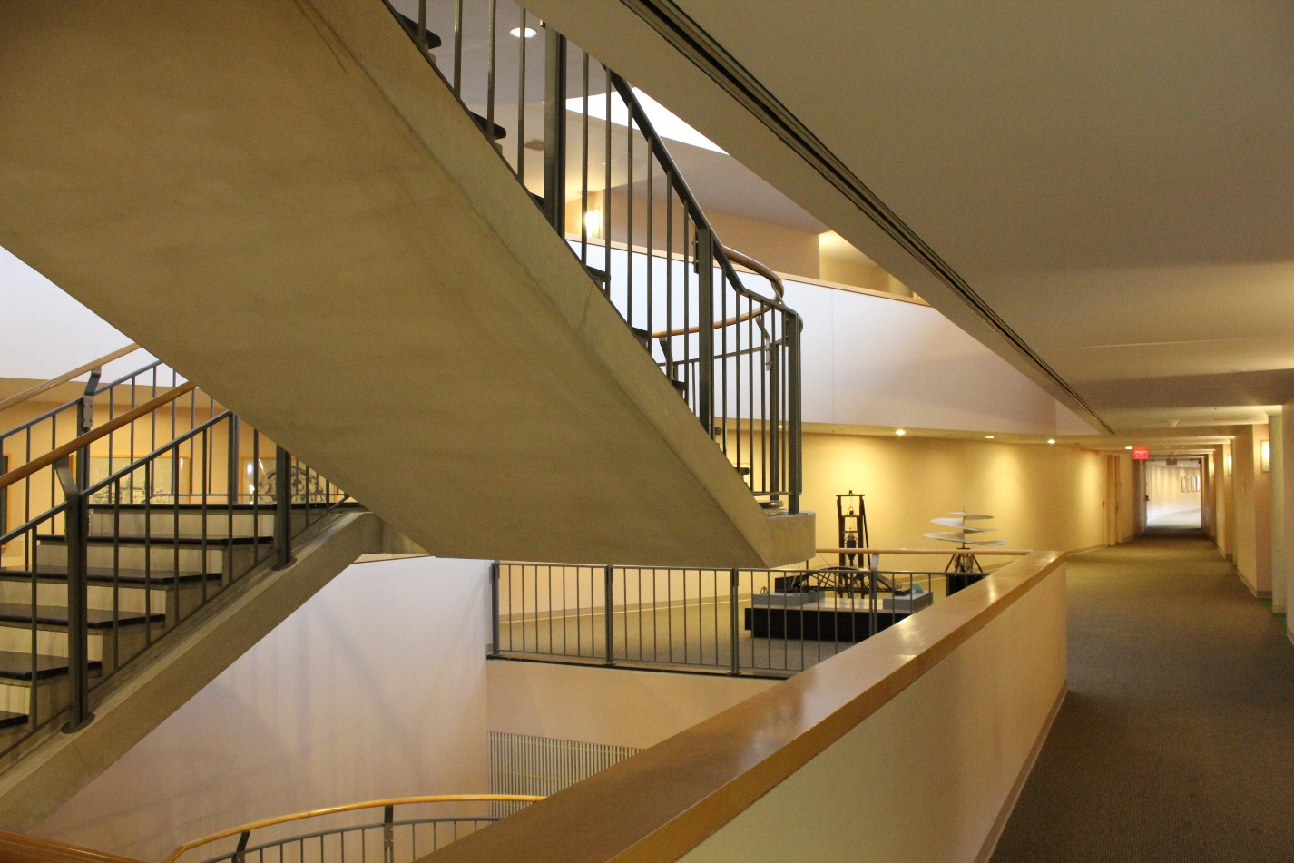

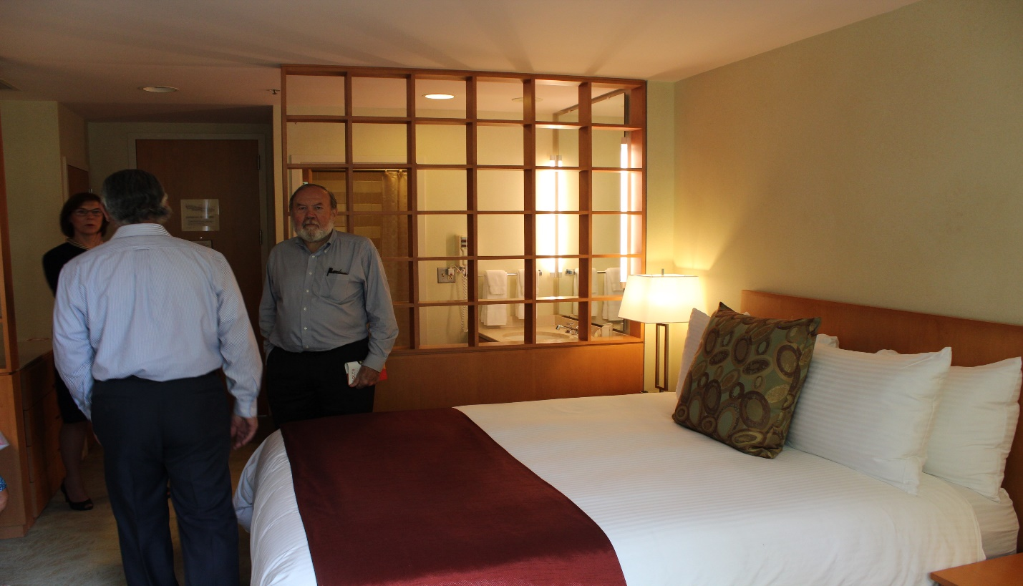

ACADEMICS:

All students spend four years in four primary subject areas: math, languages, arts and sciences. Listed in a matrix format, the four are augmented with dynamic issues requiring skills from at least two of the primary subjects. Issues draw from contemporary challenges seen in culture and its variations, beliefs in economic models, and separated society, e.g., seeing relations between health and food, social interactions and antinomy, governance of self, realizing products from ideation and concern for larger costs and benefits. A third dimension to the learning matrix allows students to learn the arts of issue formulation, problem solving and consequences. These linkages tend to be better seen via an artistic lens in that they are not linear in the history of advancing science, art and society.

Classrooms will not be assigned per class size or subject areas. Teaching and learning spaces, and their support resources, will be used in a fluid manner, much like the more successful organizations in current business practices. Economics, finance and business will be presented in a manner consistent with some of the world’s leading business programs.

THE CURRICULUM:

While the four foundation subjects remain there will be an evolution in their content and form. Traditional labels within these subject areas will generally remain intact during the four years of instruction but each course will encourage an examination of the assumptions for and edges of that subject. The traditional subject areas will be a basis for education as well as the forum for redefining their edges.

The learning in the Academy takes place within the context of these ten areas of human thought and practice:

- MATHEMATICS:

The powers of Euclidean Geometry and Newtonian metaphors can be assumed as important in the courses, as they traditionally are, but to include greater learning they are juxtaposed against the more powerful metaphors found in recent non-Euclidean Geometry and Einstein physics, where, in opposition to Euclid’s’ long held axiom 4.b, no parallel lines are needed or seen in the universe.

- SCIENCES I:
Here concepts of the most fundamental importance, according to Einstein, such as the differences between first and second laws of thermodynamics, to scientific thinking, product design and human settlements are outlined. In the way axiomatic principles, not laws, are seen as more important to the knowledge of science and thus ways to move it forward. The role of nature and the natural sciences is fundament to those working in almost all fields. Students will study the differences between those methods used to understand life by foreclosing it in order to carry out analysis, versus methods that can study living systems as they unfold and continue.
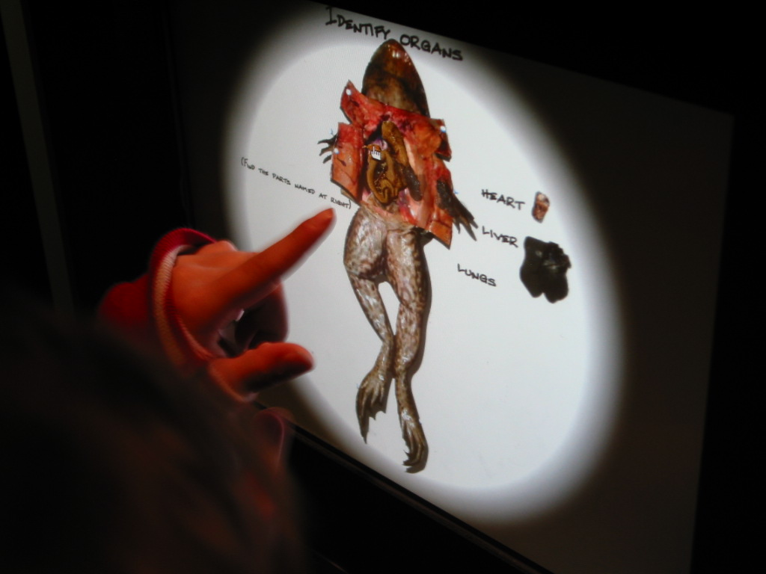

- SCIENCES II:

Fundamental differences between analytic and systemic thinking and emerging environmental changes. Analysis allows easier access by clarifying problems yet proposes little that actually resolves them. Systemic approaches allow for better responses but lack clarity in what is being responded to, except holistic phenomena. The debate and synthesis between the two approaches is crucial to learning at the Academy. Contemporary leaders such as Bill Gates made considerable use of the two approaches, where vision related to the systemic. Historic scientists, now returning as a contemporary basis for IT development, Nikola Tesla of Siberia, illustrates the same. He was the person how worked out the means in 1917 to build an energy transmission tower, upon which contemporary cell towers are based. His science for the same towers to transmit energy was suspended when it was found that the energy couldn’t be charged for. There is current discussion on methods to overcome the profit limitation to achieve climate change responses.

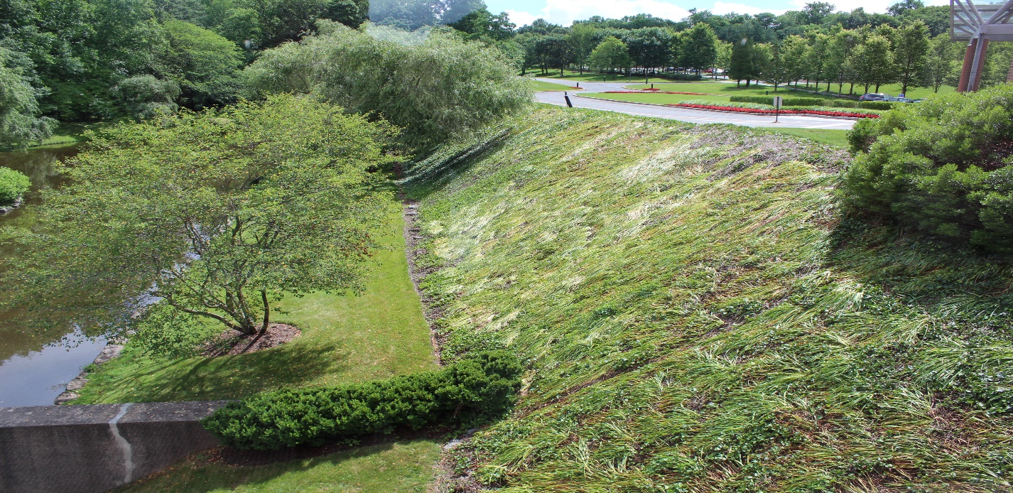

- SCIENCES III:

Here students go further into integrating the parts of science and society. For example, the role of art is now accepted as part of the leading edge of science as well as the role of science in all leading edge art. Students can do experiments to see how art, science and perceptions all strive for very different ends yet can be complementary to seeing new realities. This is easily seen in the edge of science in medical imaging in some of the NIH laboratories, such as the one at the University of Iowa, ICLIC. Science tends to see all things as different and unique but seeks a common attribute or trait. Art, on the other hand, sees all things as common and tending towards sameness, yet seeks to illustrate how each is indeed unique.

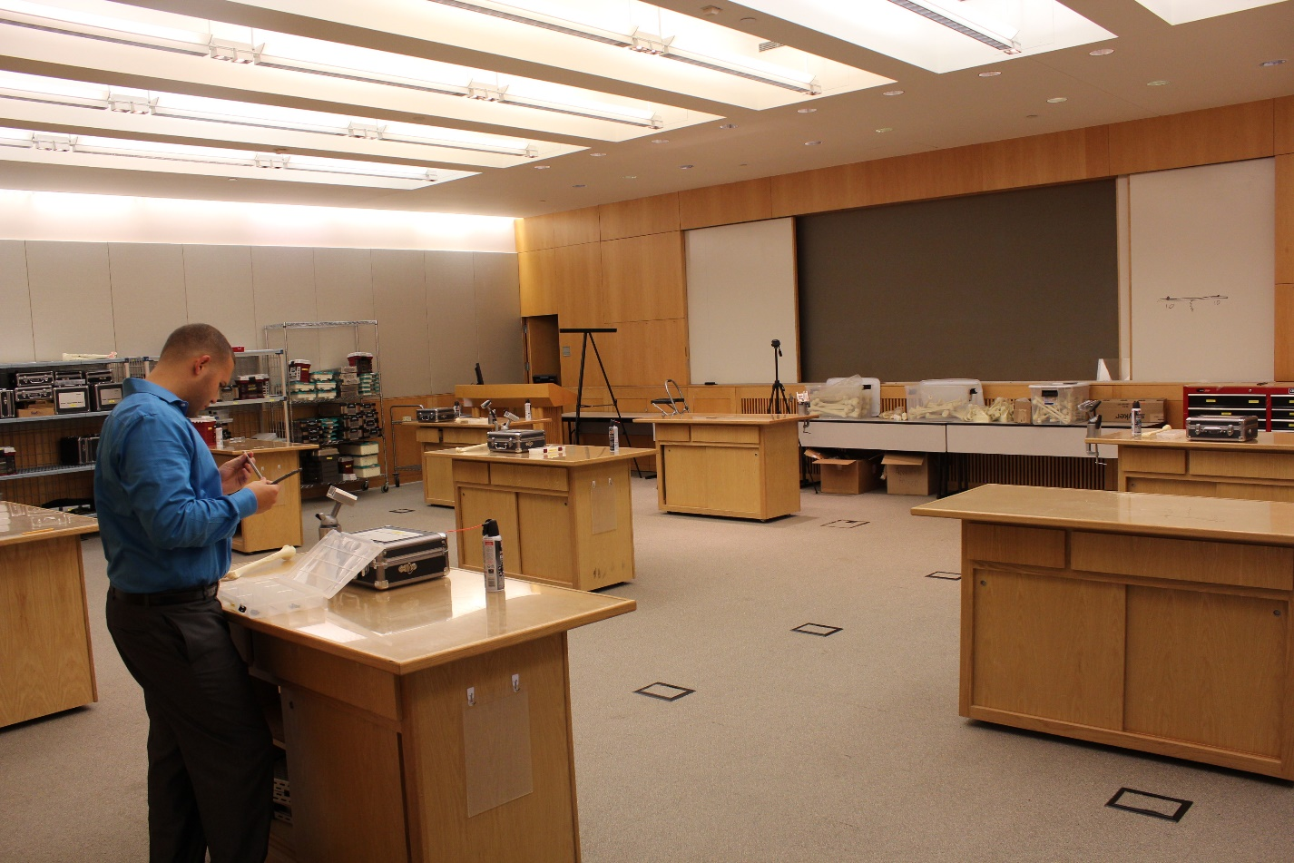

- COMPUTER SCIENCE:

The current performance of Java based computer programming will be juxtaposed against the continuing to emerge potentials in open-source alternatives, with emphasis on how IBM came to successfully define the line between idea seeking and profit seeking works that would help all involved.

- ART AND PHILOSOPHY:

The emergence of representational art, replacing the history of descriptive art, but then reemerging as computer generated art needs to be covered in light of art seen as central to defining the edges of all things human. This can be evaluated in terms of the history and philosophy of Socratic and Lao Tzu notions of art against ideology contrasted with the more widely accepted Platonic dictums and Confusion leanings that all artists should be banned from society. Classroom presentations and discussions will encourage the opening of fresh insights into the human condition and its prospects.

- LANGUAGES:

All graduates will be expected to know at least two languages to better understand the issues involved in international relations. Languages will be presented in various forms, such as how and why the common English sentence contains, and needs to contain, 50% redundancy to compensate for structural weaknesses in English, as well as how memorization is more necessary to acquire it than logic. The importance of graphic calligraphy in some languages will be contrast with the word as written in English usage, then how this creates very different forms of professional development, e.g., lawyers and the law, and the stark differences between East and West.

- HISTORY:

Our instruction of history will draw from the fundamental ideas of the great philosopher of history at Cambridge University, RG Collingwood. In his widely relied up book he goes so far as to define history as: “The interpretation of past events for present purposes, therefore the present purposes need to be included in its depiction.”

- DESIGN/PLANNING:

Human activities tend to involve the use of, or rejection from, the activities of design and/or planning. Design is mostly a three-dimensional exercise that might or might not take into account the fourth dimension of unfolding reality and how it will greet or be changed by designs. We design products, cities, homes, organizations, businesses, religions and the institutions on which humans rely for their well-being. Planning addresses the opportunities and problems of the fourth dimension and can take into account the potentials of design in the third dimension, but often do not. The best examples of design tend to include all four of the main subject areas offered in the curriculum.

- ECOLOGY/ENVIRONMETAL CONCERNS/SYSTEMS THINKING:

These issues that arise from and become informed by the life sciences are of growing importance to what societies represent and how the human project will unfold in its future. Those that are seen in their middle ages and have great need to accomplish things and “get on with it” seem to invest in ignoring the learning now available in these issues and the aspects of academic subjects they draw from. Those falling into the your and elderly age groups of a society seem more reflective about information emerging from these issues. The beliefs and insights from all three groups will be included in the learning processes of the school. The advantages and discontinuities of the industrial age and its management will provide an interesting forum for this discussion. Students will learn of the knowledge available in the major science publications, with emphasis on Science. Recent work done at Princeton points out that via climate change occupations related to current farming and construction will no longer be possible. Research done in some international firms on how humans can best respond to such conditions, as carried out in the nineteen-eighties, will be available as a topic to question.

In all these areas leading thinkers and scientists will be made use of, where emphasis will be on having the person visit the school and give lectures, then meet with discussion groups to argue over the thesis being presented. This will become an important asset to preparing for admissions to leading universities in the world. One example of this will be the very eminent IBM Thomas Watson Fellow, Dr. Richard Garwin, designer of the Hydrogen Bomb. He is also known as the father of modern submarine warfare. He gives equally fascinating lectures to White House Cabinets and high school classes on many subjects. Other thinkers invited to the school will be like the founding owner of the Finnish information technology company that created “Angry Birds”, the world’s most popular game. He is interesting in experimenting with how gaming can be instrumental to student learning. There are many other guests that the Board Members have relations with that will visit the School and interact with students.

During the past half century it has become clear that the amount of material that must be acquired and somehow retained and organized within school and life-long learning is growing. The industrial age approach to this complexity has been to create ever narrower specializations populated by ever narrower minds. The myriad of ever growing pieces could then be left to be assembled by others. For over a hundred years this approach was strongly endorsed and supported by university training, where more subjects shifted towards “practices,” “applications,” and knowable issues. This was called educational pragmatism.

Another approach, in response to the consequences of the segmented approach, and to youth not wanting to occupy categorical boxes, has come to support what has been called the information age, or more recently has shifted in a communication age. Herein youth seek a more general overview of what is going on in their world as well as normative insights into what ought the world to be like. They do this via shifting from static acquisition of knowledge to a more fluid approach. In university settings this is seen in the shift from single discipline study to students balancing two or three different degree programs then concentrating on connections between them. The most adventurous university students now select double majors as far apart as possible to become knowledgeable about all in between. In this way a graduate has the redundancy of two subjects, and spends continuous life-long education to learn of all that lies between. These are seen to be some of the most valuable employees in that they seldom become redundant as specific services and products are no longer valued in society. Students and teachers have gradually noticed that crucial to this process of dealing with complexity is learning to learn. Many examples have demonstrated one of the most effective ways to learn to learn is to teach, thus having students give presentations to others in an effort to teach others a subject is the most effective way to actually learn the subject. This school will make extensive use of this knowledge on learning to learn.

The larger context of the school will include an array of athletic facilities, events and activities for responding to human needs beyond the limits of learning about and negotiating with ideas. This will include lectures by noteworthy world athletes. The facilities and faculties of Palisades will offer doorways and bridges to many opportunities in many parts of the world. It is only for you to make use of them.

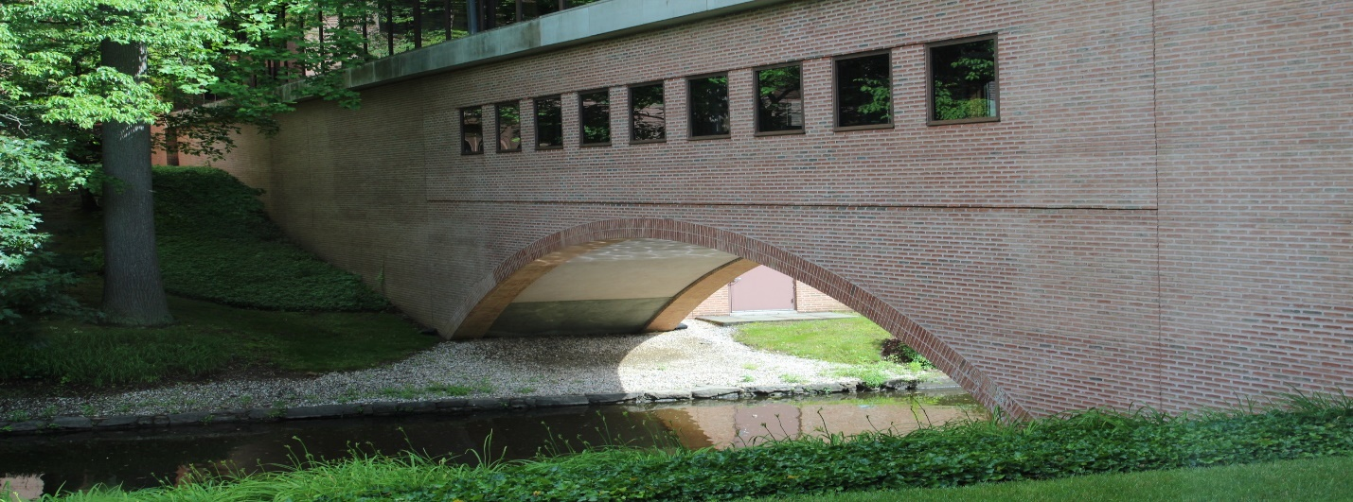
OUTCOMES:
Graduates will be well prepared to apply to and gain entry into virtually any university setting they believe to be consistent with their aspirations. The premier West Coast universities with their incredible record of starting new, non-finance businesses will also favor the graduates of the Academy, something unique for an East Coast private high school.

Some students may elect to take a year off and do post high school studies at another institute in the world related to their interests. They may want to build on their international connection developed via fellow class mates or spending a semester in another high school in the network of schools partnering with the Palisades Academy.

The study of human cultures. This includes ancient and modern languages, world philosophies, religions, and literature. It also includes the role of the visual arts as well as music, dance and theater in society. The methods to teach these subjects relies on teachers that encourage speculative and critical approaches, including the raising of questions of interpretation and implications.
Math will begin with principles and problems in Algebra, Geometry, Pre-calculus, Calculus and ending with Linear Algebra and Statistics. These will be presented along with the evolution of problems in physics, astronomy, and natural and social sciences.
Science study will cover basic precepts, bodies of knowledge and questions as the edge of the physical sciences, biology, and chemistry, including what is known as the natural and unnatural sciences. In the fourth year students will select particular problem areas where science defines the edges of that area. These can include: physics, chemistry, marine science, astronomy, physiology and environment.
This is the world’s most popular game for high school students. Gaming, via open systems
Business Ontology was a popular subject for executive business students in the New York, Stockholm, Sweden and Helsinki Finland where it focused on the edges of business knowledge, then how to move them.
Leading students in leading universities often do this by pursuing double majors that are not adjacent.
Logic typing is used in many college courses to define differences in subjects by identifying the differences in presumptions beneath each subject. For example, in software design there is a fundamental difference between frameworks based on hierarchies and those based on non-hierarchical networks, where the second are far faster and less prone to viruses and breakdown. This comes out of the redundancy of functions vs that of parts logics.
Leading scientists often remark that unless viable responses to a problem are contradictory the problem is not worth their time.
This is consistent with some of the accomplishments of Russell Ackoff in business education in companies and universities, such as at the Wharton School. His model bought Wharton to the front ranks of business education. Crucial in this is the concern of living systems sciences with how do you study life without needing to close it down to dissect and analyze it; e.g., the famous frog dissection dilemma in high school biology classes worldwide.
His most recent work is seen in June 25, 2014 Science, “Not-seeing is believing.” Pp. 1436-1437. He and Dr. Hawk organized workshops and conferences for the American Association for the Advancement of Science.

