Appendix A
I am presently counselling a client who is a secondary school teacher and the head of her department. She is striving to make meaning of a number of life stressors: an unreasonable workload, a chronic terminal illness that is affecting both herself and several other family members, a problematic personal relationship, a stressful relationship with a colleague, an aggressive and disruptive staff member who is underperforming and a group of difficult students whose parents and grand parents are in consultation with her.
This client was referred to me by a colleague who was concerned that she may be burning out and considered I had the appropriate expertise to assist. When she arrived to our first four sessions she was very tense and after her second session I became concerned about a particular tension I perceived in her demeanour because despite her circumstances I could not make sense it. I decided to take her case to supervision. My supervisor suggested that I address the tension with the client directly. When I felt there was a strong enough relationship to do so I asked her about the tension and she revealed to me that she was attending sessions with me in secret. She has deliberately chosen not to inform her partner, friends, family or workplace that she was seeking support. Figure 12 illustrates many of the relationships that are relevant to the constitution of the supervision space in the case of this client, either by the subject’s direct involvement or by their poignant absence.
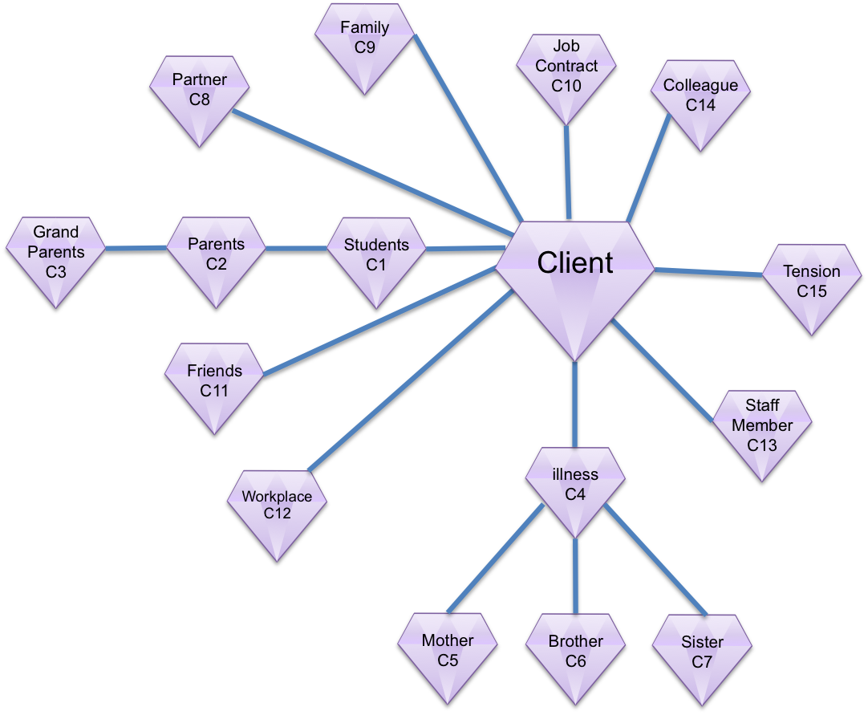

Figure 12: The primary and secondary contextual levels of the client

The relationship graph (Figure 12) illustrates some of the objects, subjects and relationships that are present within this clients secondary level context fan for one moment in therapy. The client has not spoken about any relationships that her mother, brother and sister have with each other, only the relationship she has with each of them. Consequently, I have not included any relationships between these subjects other than their link to the client. The client has spoken of the relationships between the troubled students, their parents and grandparents. These are linked to the client and to each other.

Key | Description
Practitioner/Supervisee
P1 | Family
P2 | Parents
P3 | Grandparents
P4 | Illness
P5 | Mother
P6 | Brother
P7 | Sister
P8 | Previous client experience
P9 | Previous supervisee/supervisor experiences
P10 | Past job contracts
P11 | Relationship with teachers
P12 | Experiences of being a student
P13 | Staff
P14 | Professional Organisation
P15 | Experiences with colleagues
P16 | Experiences of being a teacher
P17 | Partners & past partners
P18 | Friends supportive & unsupportive
P19 | Experiences of workplace
P20 | Colleague
P21 | Tension
Supervisor
S1 | Family
S2 | Parents
S3 | Grandparents
S4 | Illness
S5 | Mother
S6 | Brother
S7 | Sister
S8 | Previous client experience
S9 | Previous supervisee/supervisor experiences
S10 | Past job contracts
S11 | Relationship with teachers
S12 | Experiences of being a student
S13 | Staff
S14 | Professional Organisation
S15 | Experiences with colleagues
S16 | Partners & past partners
S17 | Friends supportive & unsupportive
S18 | Experiences of workplace
S19 | Gender Difference
S20 | Cultural Difference
S21 | Children
S22 | Colleague
S23 | Tension

Figure 13: Key for Figures 14 and 15

In supervision, both my supervisor and myself draw on our sense of self to make sense of this client’s needs. Aspects of self that come into the foreground include: our experiences with past clients, our own experiences of teachers, difficult students, their parents and grand parents, ourselves as students, our parents and grand parents, our experiences of carrying unreasonable workloads, problematic personal relationships, stressful relationships with colleagues and aggressive and disruptive staff, gratitude towards supportive colleagues and our understandings of chronic terminal illness and its impacts on family. These, and the quadrant participants are the main subjects that present in the secondary supervision context.
Less visible lexical objects that enter the supervision context include contracts such as the supervision contract, the therapeutic contract and the client’s job contract and HOD role. Conceptual objects include our joint and conjoint perceptions of supervision, tension, demeanour, illness, choice, aggression, disruption, underperforming, burn out, making sense, circumstances, secrecy, absence and presence, to address directly, to seek support.
We also bring an awareness of how the client is having experiences that we have not had and that their ‘meaning making’ with respect to the experiences that we share may not be the same as our own.
Figures 14 and 15 illustrate the primary and secondary contextual levels of the supervisee and supervisor. Figure 13 is a key that provides descriptions of the entities that each of the jewels in figures 14 and 15 represent. Figures 12, 14 and 15 are combined in Figure 16, which provides an illustration of the total supervision quadrant relationships at primary and secondary contextual levels. When these relationships are viewed summatively it becomes possible to see the emergent relationships that result. This phenomena is discussed in the body of the essay.

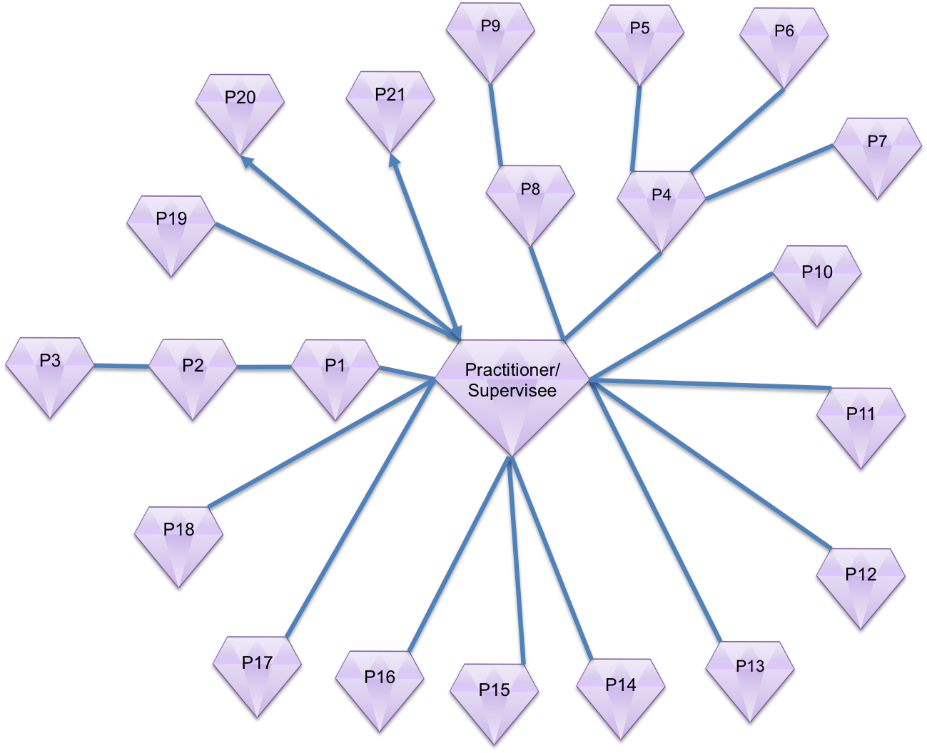

Figure 7: The primary and secondary contextual levels of the supervisee

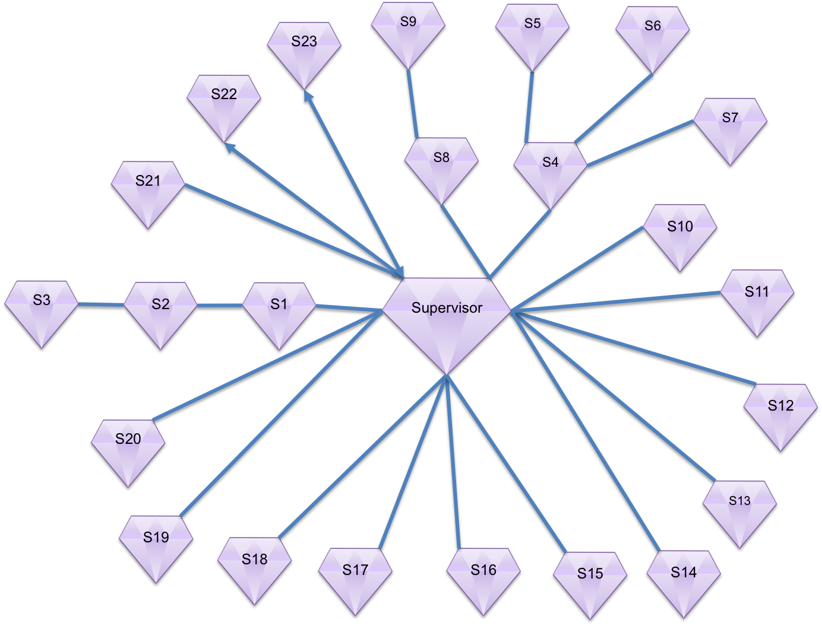

Figure 8: The primary and secondary contextual levels of the supervisor

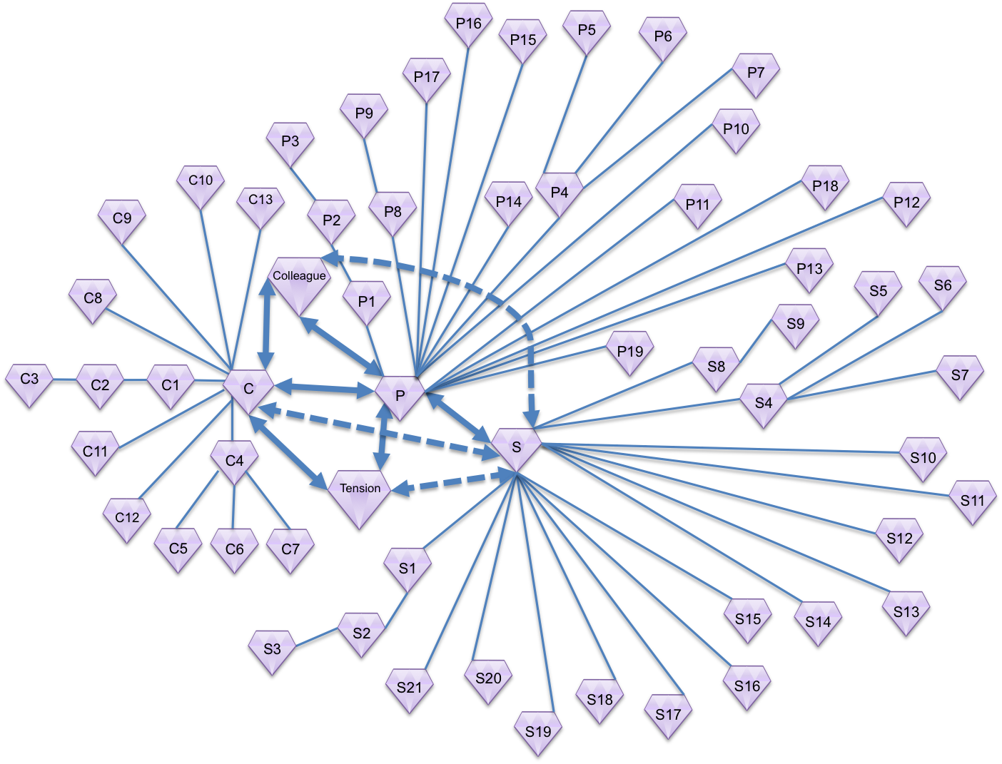
Figure 10: The total supervision quadrant relationships at primary and secondary contextual levels

